Regression analysis

Elevation<- c(600,700,1000,1300,1200,1450,950,1100,2000,1750,1350,1500)  
Temperature<-c(45,50,46,47,35,39,40,30,50,29,50,40)  
plot(Elevation,Temperature)  
abline(lm(Temperature~Elevation),col="red")

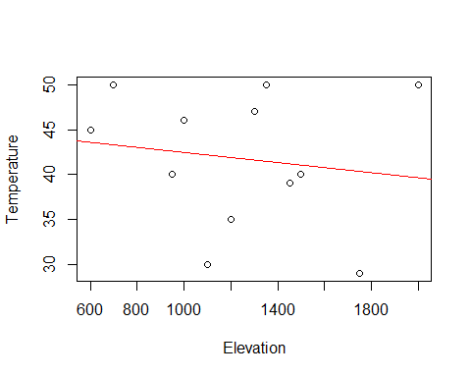

We can use summary to dig deeper into linear model

lm1<- lm(Elevation~Temperature)  
summary(lm1)

##   
## Call:  
## lm(formula = Elevation ~ Temperature)  
##   
## Residuals:  
## Min 1Q Median 3Q Max   
## -614.55 -256.34 2.08 199.97 827.17   
##   
## Coefficients:  
## Estimate Std. Error t value Pr(>|t|)   
## (Intercept) 1590.004 718.883 2.212 0.0514 .  
## Temperature -8.343 16.969 -0.492 0.6336   
## ---  
## Signif. codes: 0 '***' 0.001 '**' 0.01 '*' 0.05 '.' 0.1 ' ' 1  
##   
## Residual standard error: 422.6 on 10 degrees of freedom  
## Multiple R-squared: 0.0236, Adjusted R-squared: -0.07403   
## F-statistic: 0.2418 on 1 and 10 DF, p-value: 0.6336

The result shows from P-value that way larger than 0.05, so elevation may not be a good independent variable to temperature